
Trinity Occupational and Public Health Solutions Ltd
5 Pelham Court
Pelham Road
Nottingham
NG5 1AP

T: 0115 8373650 | F: 0845 8624111 | www.tophs.co.uk | enquiries@tophs.co.uk
Nottingham Network Clinic
Location
5 Pelham Court is situated 1 mile North of Nottingham City Centre; on Pelham Road, which is located off the A611 Hucknall Road which forms a major arterial route within the City, linking Mansfield Road (A60) and Valley Road (A6514) with A610 Junction 26 M1 Link). We are within walking distance of a NET Tram Stop [The Forest] with direct links to Nottingham City Centre, the Train Station and surrounding suburbs. There is some parking available on site.
What3Words: ///healtheir.pints.given

Drive Times
From City Centre & Nottingham Train Station – 10 minutes
Nottingham East Midlands Airport – 25 minutes
London – 2 hours 10 minutes
Junction 26 M1 Motorway – 15 Minutes
Post Code for SAT NAV: NG5 1AP
Contact - Reception – 0115 8373650
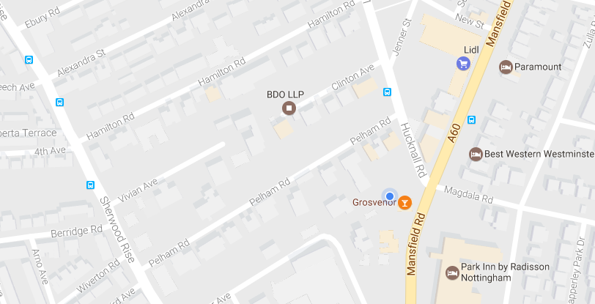
Turn on to Pelham Road from Hucknall Road and Pelham Court is the first driveway on the left. We are located at the rear of the building.

